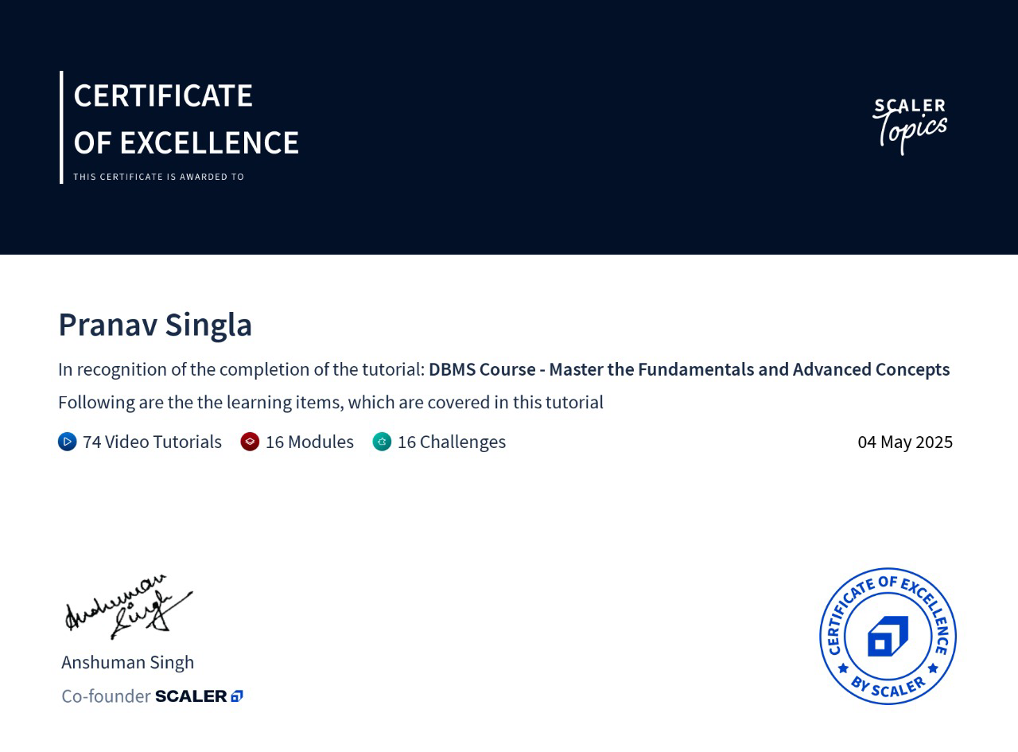
Anjany Kumar Jaiswal

